GGN - Geopark Annual Report 2018
1.Geopark Identity
The year for initial joining/the year for the last revaluation: 2006/2016
Name, Country of the territory and Regional Network: Wangwushan-Daimeishan UNESCO Global Geopark, China, APGN
Joining Year/ Last Revalidation Year: 2006/ 2016

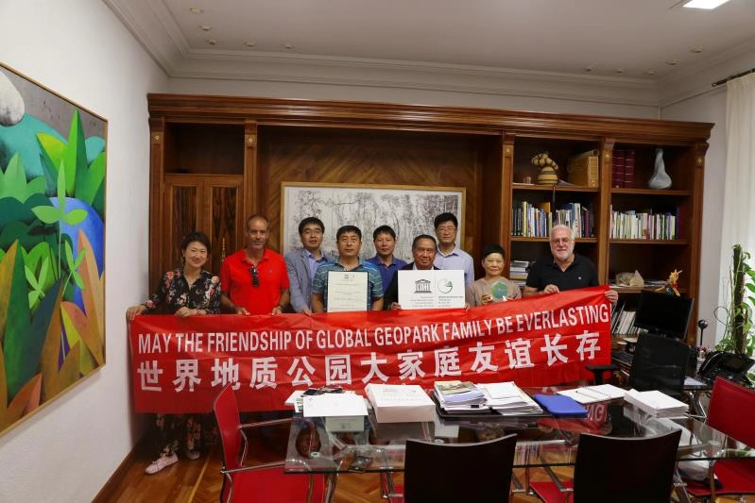
Representative Photo (from the most important event this year)
Annual representative activity: in August 2018, Wangwushan-Daimeishan Geopark visit Villuercas Ibores Jara UGGp of Spain for international sister-park exchange activity
2. Data of the Geopark
Number of the Staff: 180 staff including 6 geoscientists
Number of Visitors: 15,400,000
Number of Activities：18

充分利用世界地球日、全国科普日等平台，相继开展了研学旅行、少年科普行、科普知识进校园、科普知识竞赛等活动；举办了桃花节、红叶节、黄帝祭天大型实景演出、小沟背女娲文化旅游节、自行车骑行赛、重阳登高节等旅游文化活动。
Taking full advantage of such events as the World Earth Day and the National Science Popularization Day, the Geopark successively carried out such activities as school trips, science fieldtrips for teenagers and science popularization knowledge competitions, and also such tourism and cultural activities as Peach Blossom Festival, Red Leaf Festival, Large-scale Live-action Performance regarding Sacrifice to Heaven by the Yellow Emperor (a legendary ruler in ancient China), Xiaogoubei Nuwa (a goddess in Chinese mythology) Cultural Tourism Festival, Bicycle Riding Competition, Double Ninth Festival (or “Height Ascending Festival”).
开展地质公园教育计划的学校班级数：12个
Number of Classes Implementing Geopark Educational Plans: 12
地质公园发表新闻稿数量：向世界地质公园网络中心报送信息12条，发表4条；在GGN通讯发表信息1条；在公园官方网站发表信息25条。
Number of News Published: 12 pieces of news were submitted to the Global Geoparks Network with 4 ones therein being published; 1 piece of news were published on GGN Newsletters and 25 ones were published on the official website of the geopark.
3. What We Have Done in 2017
Main achievements in 2018
一是全面推进小沟背景区古火山地质遗迹保护与监测设施建设项目；二是开展了河南省国土资源科普基地联展活动；三是积极开展交流与合作，分享地质公园先进经验；四是全年共开展了两次大规模地质科普宣传活动，分别是“王屋山-黛眉山世界地质公园走进济源市职业技术学院举办地学科普进校园专题讲座暨赠书”和“科普志愿者集训营” 活动；五是加强公园所辖景区投资建设，新建玻璃栈道、玻璃观光平台、悬崖秋千等娱乐项目，丰富了游客的娱乐活动。
First, we promoted the project on the geoconservation of ancient volcanoes within Xiaogoubei Scenic Area and the construction of relevant monitoring facilities therein; second, carried out the joint exhibition of Land and Resources Science Popularization Bases of Henan Province; third, actively implemented exchanges and cooperation to share advanced experience of Geopark; fourth, held two large-scale geological science popularization activities, namely the “Special Lecture & Book Donation by Wangwushan-Daimeishan Geopark on the campus of Jiyuan Vocational and Technical College” and the “Science Popularization Volunteer Training Camp”; fifth, strengthened investment in the Geopark, and built such recreational projects as glass walkway, glass sightseeing platform and cliff swing, offering more recreational activities for tourists.

Contribution to GGN: Network Activities and Participation
1、参加了在意大利举办的第八届联合国教科文组织世界地质公园大会；2、参加了在雁荡山世界地质公园举办的2018年中国联合国教科文组织世界地质公园年会，并在会上散发了王屋山-黛眉山世界地质公园相关宣传资料；3、与姊妹公园西班牙维约尔卡斯-伊博尔-哈拉世界地质公园开展国际姊妹公园交流活动；4、参加了姊妹公园丹霞山世界地质公园组织的“2018年文化和自然遗产日系列活动”；5、参加了河南省地质环境保护与地质旅游发展促进会开展的“山水大讲堂”，并就世界地质公园建设与可持续发展作了典型发言。
1. Participated in the 8th Conference on UNESCO Global Geoparks held in Italy; 2. participated in the 2018 Annual Meeting of UNESCO Global Geoparks held in Yandangshan Geopark, and distributed relevant promotional materials of Wangwushan-Daimeishan Geopark at the meeting; 3. held international sister-park exchange with the sister park Villuercas Ibores Jara UGGp of Spain; 4. participated in “a series of activities regarding Cultural and Natural Heritage Day 2018” organized by the sister park Danxiashan Geopark; 5. participated in “Shanshui Lecture Hall” held by Henan Provincial Geological Environment Protection and Geological Tourism Development Promotion Association, and gave a typical speech on the management and sustainable development of global geoparks.
管理和财务状况
Management and Financial Status
管理机构：2010年成立了由济源、洛阳新安县两地市（县）长为领导的王屋山-黛眉山世界地质公园管理委员会，共同协调解决公园建设、管理、保护等方面问题；2012年，管理委员会下设王屋山-黛眉山世界地质公园管理局，对公园进行统一建设和管理。
Management Body： the Wangwushan-Daimeishan UNESCO Global Geopark Management Committee led by the mayor (magistrate) of Jiyuan and Xin’an County, Luoyang City was established in 2010, taking charge of the development, management and conservation of the Geopark; the Wangwushan-Daimeishan Geopark Administration was established directly under the Management Committee in 2012, taking charge of the development and management of the Geopark.
财务状况：财务状况良好，2018年旅游收入1.87亿元。
Finance status: sound and stable. The tourism income in 2018 reached 187 million RMB.

地质遗迹保护
Geoconservation
编制了公园总体规划、地质遗迹保护规划；出台了公园管理办法和地质遗迹保护管理规定；对公园内重要的地质遗迹点设置了保护牌，并定期进行巡查和监管。
Prepared a master plan of the park and a protection plan for geoheritages therein; introduced measures for the management of the park and regulations for the protection and management of geoheritages; set up protection plates for important geological relic points within the park, accompanied by regular patrol inspection and supervision.
可持续旅游（地学旅游）
Sustainable Tourism (Geotourism)
世界地质公园的建设对拉动地方经济起到了积极作用。2018年，新增长期工作岗位100个，临时岗位80个，有效促进了当地旅游经济可持续发展。
The construction of the geopark has played an active role in promoting the development of local economy. In 2018, we set another 100 long-term posts and 80 temporary ones for the geopark, effectively advancing the sustainable development of local tourism economy.
New Educational Plans concerning Geoheritage Conservation, Sustainable Development and Disaster Risk Relief
制定了《王屋山-黛眉山世界地质公园2018年度地学科普宣传教育活动计划》，开展了4.22世界地球日、全国科普日等科普活动；充分利用科普教育活动中心开展了“少年科普行”（参与人次2000人）、“地质公园研学旅行”（参与人次20000人）、“科普知识进校园”（参与人次1000人）等科普活动。
Prepared the Plan for Geological Science Popularization and Educational Activity of Wangwushan-Daimeishan Geopark in 2018, and carried out such science popularization activities as World Earth Day and National Science Popularization Day; while making the best of the Science Educational Activity Center, such activities as “Science Popularization Trips for Teenagers” (2,000 participants), School Trips to Geoparks (20,000 participants) and Science Educational Activities at Schools (1,000 participants).
Strategic Partners
公园所辖王屋山景区成为河南理工大学教学实践基地；与青年旅行社、大河旅行社、济源市教育局联合开展“地质公园研学旅行”活动；与愚公学校、沁园路小学、济源市职业技术学院共同举办了地质科普知识进校园活动；与伏牛山世界地质公园、西班牙维约尔卡斯伊博尔哈拉世界地质公园进行了互访学习。
Wangwushan Scenic Area under the jurisdiction of the Geopark became the teaching practice base of Henan Polytechnic University; joined hands with the Youth Travel Agency, Dahe Travel Agency and Jiyuan Education Bureau in carrying out the “Geopark Study Tour”; held the geoscience educational activities together with Yugong School, Qinyuan Road Primary School and Jiyuan Vocational and Technical College; visited Villuercas lbores Jara Geopark of Spain wirh Funiushan Geopark.
Promotional Events
相继在公园所辖荆紫仙山、王屋山景区举办了“桃花节”、“红叶节”、“登高节”、 小沟背女娲文化旅游节等公园特色节庆活动；举办了“探索地球奥秘——走进王屋山”、“小沟背火山峡谷游”等地学文化旅游活动；举办了 “河南理工大学音乐学院师生走进王屋山”、“三月三逛庙会、看大戏”、“荆紫仙山牡丹花会”、“黄河三峡野玫瑰节”、“洛阳黛眉山旅游文化节”、“龙潭峡自驾游”、“寻找荆紫仙山锦鲤”等营销活动，并借助微信、官网以及各级媒体、报纸、广告塔等，对公园进行全方位宣传。
We successively held such festivals as “Peach Blossom Festival”, “Red Leaf Festival” and “Xiaogoubei Nuwa (a goddess in Chinese mythology) Cultural Tourism Festival”, such geological cultural tourism activities as “Exploration on the Mysteries of the Earth - Visit to Wangwushan” and “Trip to Xiaogoubei Volcano Canyon”, and such marketing activities as “Visit of teachers and students of the School of Music of Henan Polytechnic University to Wangwushan”, “Temple Fair and full-scale drama on March 3”, “Peony Show in Mount Zijing”, “Wild Rose Festival in Three Gorges, Yellow River”, “Cultural Tourism Festival in Mount Daimei, Luoyang”, “Self-driving Tour to Longtan Gorge” and “search for lucky dog in Mount Zijing”. In addition, we also made an all-around propaganda on the park by means of WeChat, our official website as well as media at all levels, newspapers and advertising towers.

4. Contact Persons
Manager: MLiu Xiaoling xiaoling3998@163.com
Geoscientist: Zhang Zhonghui zzhui62@163.com

